# MobyGames

## Definition

**# Source**: **Windows ScreenShots From Site -> https://www.mobygames.com/ at [8/27/2025]**

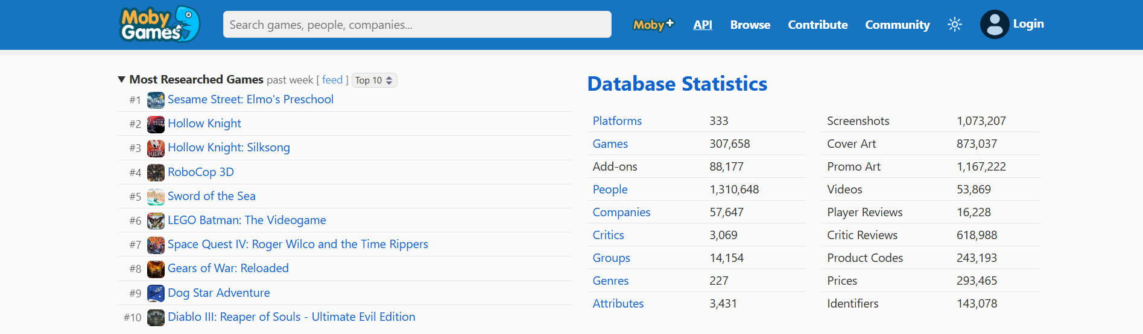

**# Source**: **Chatgpt (GPT-5-Standard) at [8/27/2025]**

**MobyGames** is a comprehensive online database that documents video games across all platforms. It provides detailed information about game releases, developers, publishers, genres, platforms, cover art, screenshots, and user reviews. The site is widely used by gamers, researchers, and historians to track video game history and collect detailed metadata on games.

## Key Highlights

**# Source**: **Chatgpt (GPT-5-Standard) at [8/27/2025]**

* **Extensive Game Database:** Covers games from classic consoles, PC, mobile, and modern platforms.
* **Detailed Metadata:** Includes release dates, platforms, publishers, developers, and credits.
* **User Contributions:** Users can submit reviews, screenshots, and corrections to improve the database.
* **Historical Archive:** Acts as a reference for gaming history and development evolution.
* **Community Features:** Forums and discussion boards allow users to connect and share insights.

## Summary Table

**# Source**: **Chatgpt (GPT-5-Standard) at [8/27/2025]**

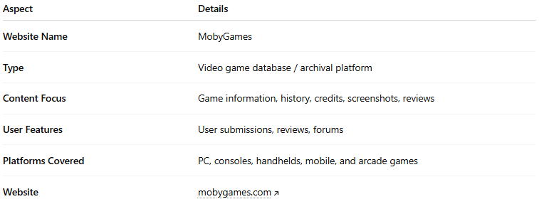

| **Aspect** | **Details** |
| --- | --- |
| **Website Name** | MobyGames |
| **Type** | Video game database / archival platform |
| **Content Focus** | Game information, history, credits, screenshots, reviews |
| **User Features** | User submissions, reviews, forums |
| **Platforms Covered** | PC, consoles, handhelds, mobile, and arcade games |
| **Website** | [mobygames.com](https://www.mobygames.com/) |

MobyGames is essentially a **video game encyclopedia** that serves both casual gamers and researchers looking for detailed and historical information about video games.